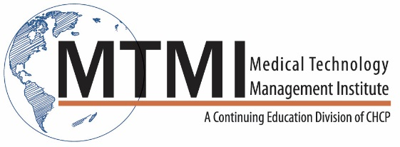
Sample 2 Day Bone Densitometry In-Service Course Agenda
16 Hour Program / 2 Day
This activity provides the 16 hours of structured education related to the content specifications outlined by the ARRT, required for certification and registration.
Bone Densitometry Overview
Patient Care and Management
- What is Bone Densitometry?
- Why Bone Densitometry?
- The history and present techniques
- Advantages and disadvantages
- DXA technology in vertebral fracture assessment
- DXA technology in body composition assessment
Suggestions for setting up a Bone Densitometry room/office/ laboratory
Procedures and Image Production
- Discuss what is expected from reception staff
- Educational materials
- Bone densitometer room set-up
- Apply state rules/regulations for record keeping
- Understand the importance of archiving and backing up
- Communication with all operators of the equipment
An Overview of Osteoporosis
Patient Care
- Stats and facts
- Bone physiology
- Risk factors
- BMMA
- Evaluation
- Prevention and treatment
- Laboratory tests
Principles and Instrumentation of DXA equipment
Image Production
- DPA
- DXA
- What are x-rays?
- Two methods of x-ray production
- Radiation detection
- Pencil beam vs fan beam
- Variables measure in DXA
- Precision
- Equipment characteristics
- Operator and patient characteristics
- Follow-up scanning
Quality Control
Image Production
- Define quality control
- Phantoms
- Utilize the phantoms to make control tables/charts
- Types of QC
- Relocation of DXA units
- Cross calibrations
- Upgrades
Radiation Safety
Patient Care
- State regulations
- ALARA
- Principles of radiation protection
- Radiation quantities
- Patient preparation
Procedures
- Forearm DXA scanning
- Proximal femur DXA scanning
- PA lumber spine DXA scanning
Scanning Techniques / Demonstrations
Case Studies
ARRT Exam Preparation / Content Specifications

~ Agenda Subject to Change ~

800-765-6864 ~ custservice@mtmi.net ~ www.mtmi.net

