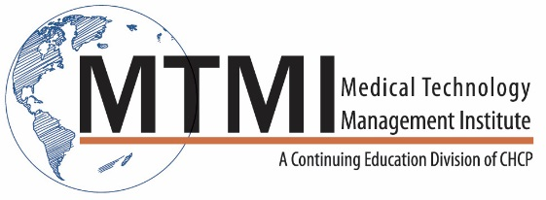

Sample Breast Ultrasound Course Agenda
16 Hour Program / 2 Day
This activity provides the 16 hours of structured education related to the content specifications outlined by the ARRT, required for certification and registration.
Day One
Basic Physics of Ultrasound
- Ultrasound wave characteristics
- Fundamentals
- Bio-effects
Breast Anatomy and Physiology
- Physiologic characteristics
Benign and Malignant Features
- Margins
- Echogenicity
- Shape
- Heterogeneity
- Compressibility
- Vascularity
Instrumentation and Technique
- Transducers
- Technical factors
- Safety and bio-effects
- Image orientation
Patient Care
Accreditation
- Mammography
- Breast Ultrasound
Mammographic Correlations
Artifacts (image production)
Shadowing, Enhancement, Reverberation
Instructor Led Hands-on Workshop

Day Two
Benign Breast Lesions
- Cysts
- Fibrocystic change
- Fibroadenoma
- Papilloma
- Hamartoma
- Inflammation and infection
- Trauma
- Gynecomastia
- Diabetic Mastopathy
Malignant Breast Lesions
- Statistics
- Ductal Carcinoma In Situ
- Lobular Carcinoma In Situ
- Invasive Ductal / Lobular CA
- Breast Neoplasms
- Medullary CA
- Colloid CA
- Papillary and Tubular CA
- Uncommon Malignant Breast Neoplasms
Other Imaging Modalities
- BIRADS and assessments
- Ductography
- MRI, DBT, NM, PET/CT
- Implant imaging
- BSGI / PEM
Emerging Technologies
Instructor Led Hands-on Workshop

~ Agenda Subject to Change ~

Educational Objectives
At the completion of the program, participants will be able to:
- Recognize normal breast anatomy on the ultrasound image and evaluate lesions for their benign or malignant features.
- Recall the mammographic and ultrasonic features of specific benign and malignant lesions.
- Recognize breast ultrasound artifacts, understand why they occur and describe techniques to minimize the occurrence of those that degrade the image.
- Understand the techniques use to correlate mammographic images to ultrasound images.

800-765-6864 ~ custservice@mtmi.net ~ www.mtmi.net

