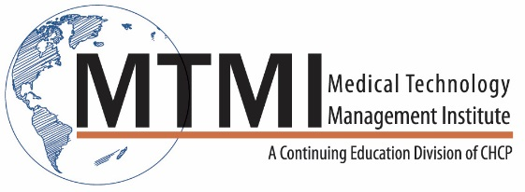
Computed Tomography Clinical Assessment
8 Hour Program
2 – Day Program
Meet with Management Team – ACR Accreditation Review
- Protocol development strategies to meet ACR accreditation standards and ACR
- AAPM dose guidelines in CT (Image Wisely)
Image Quality Considerations (All CT Technologists must participate from 8:30am to 12:00pm)
- Contrast/spatial/temporal
- Noise
- Linearity
- Uniformity
CT Scanning Protocols/consistency
- Image Critique
- ACR Accreditation requirements
Review Protocols/work with site technologist
- How to setup consistent protocols
- Requirements from site leadership team

~ Agenda Subject to Change ~

800-765-6864 ~ custservice@mtmi.net ~ www.mtmi.net

