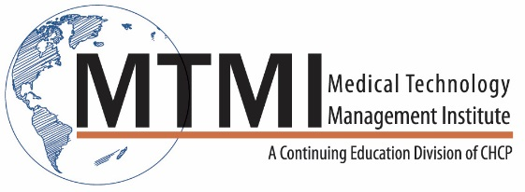
CT: Image Optimization, Case Studies and Dose
Dose Considerations
Measurements
- Benchmarks
- ACR accreditation dose limits
Improving Image Quality
Spatial Resolution
- Contrast Resolution
Neuro CT
Brain
- CT Angiography
- Circle of Willis
- Perfusion studies
Neuro Pathology and Disease Processes
Neck CT
- Soft Tissue studies
- CT Angiography – Carotid
Neck CT Pathology and Disease Processes
Thorax CT
- Routine Studies
- High resolution CT
Thorax CT Pathology and Disease Processes
Abdomen/Pelvis CT
- Inflammatory Processes
- Bi-Phase Exams
- Tri-Phase exams
- Genitourinary Systems
- Gastrointestinal System
- Abdomen and Pelvis
Pathology and Disease Processes
- Vertebral Column
Vertebral Pathology and Disease Processes
~ Agenda Subject to Change ~

800-765-6864 ~ custservice@mtmi.net ~ www.mtmi.net

