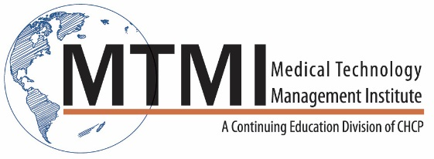
Sample 1 Day CT and MRI Evaluation of Common Pathologies
8 Hour Program / 1 Day
CT Imaging Review
- The Fundamentals
MR Imaging Review
- The Fundamentals
Evaluating brain pathologies with CT and MRI
- Brain Anatomy Review
- Case #1
- Case #2
- Case #3
Evaluating Chest Pathologies with CT and MRI
- Chest Anatomy Review
- Case #1
- Case #2
- Case #3
Evaluating Abdominal/Pelvic Pathologies with CT and MRI
- Abdomen and Pelvis Anatomy Review
- Case #1
- Case #2
- Case #3
- Case #4
Objectives:
At the completion of this seminar, participants will be able to:
- Optimize CT protocols for the image quality, contrast enhancement and safety.
- Optimize MR protocols for image quality, contrast enhancement and safety.
- Recognize and follow the ‘checklist’ approach in diagnostic imaging and interpretation, asi relates to technologists performing CT and MR exams.
- Identify Patient preparation, screening and safety techniques for CT and MR exams.
- Develop a more comprehensive understanding of pathologies commonly evaluated with CT and MRI.
~ Agenda Subject to Change ~

800-765-6864 ~ custservice@mtmi.net ~ www.mtmi.net

