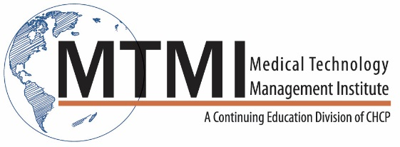
CT Registry Review
2 Days
16 Hours of Structured Education
Patient Care
- Patient prep and screening
- Assessment & monitoring
IV Procedures
Contrast Media
- Oral and IV Options and Applications
- Safety
- Efficacy
Radiation Safety and Dosimetry
- Measures, Definitions and Acronyms
- Image Quality Dose Balance
- Dose reduction, Dose modulation
Physics and Instrumentation
CT Components

Image processing and display
- Data Acquisition
- Image Reconstruction
- Image display
Anatomy and procedures
Head
- Cranium and Facial bones
- Brain – gray and white matter
- Vascular system
- Procedures
- Pathologic conditions
Neck and Spine
- Soft tissue structures of the neck
- Vascular
- Spine
- Procedures
- Pathologic conditions
Thorax, Abdomen and Pelvis
- Cardiac and Vascular
- Respiratory
- GI, Urinary, Hepato-biliary
- Reproductive
- Procedures
- Pathologic conditions

~ Agenda Subject to Change ~

800-765-6864 ~ custservice@mtmi.net ~ www.mtmi.net

