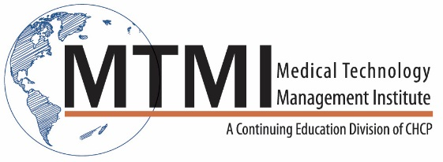
*Faculty

Miranda M. Lyman-Hager, RT(R)(M)
Michele Sisell, RT(R)(M)(BS)
Cheryl Seastrand, RT(R)(M)(BS)
Marjorie Denis, RT(R)(M)(MHA)
Pam Fulmer, BA, RT(R)(M)(QM)
Jerry A. Thomas, MS, DABR, CHP, DABSNM

*Faculty assigned by MTMI taking into account availability and expertise.

800-765-6864 ~ custservice@mtmi.net ~ www.mtmi.net

