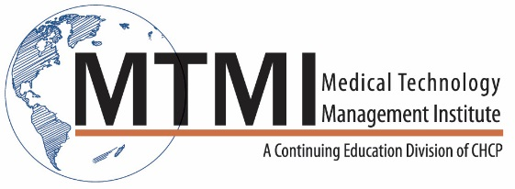
Sample 1 Day MRI Safety and MSK Imaging Course Agenda
8 Hour Program / 1 Day
MRI Safety
- Static Magnetic Field
- 5 Gauss Line
- Translational Forces (projectile effect)
- Rotational Forces (implants and equipment)
- Ferromagnetic Detectors and Hand Held Magnets
- Times Varying Magnetic Fields
- Acoustic Noise
- Peripheral Nerve Stimulation
Thermal Injuries
- RF Coils
- 1.5 T vs. 3T differences
- Specific Absorption Rate
- MRI Modes of Operations
- Thermal Burns
  - Proximity, Reflective, Resonant Circuitry, Focal
Implant Clearances
- MRI Screening
- Implants Labeling
- Active Implants
- B1 + rms
- Spatial Gradients
- MRI Safety Officer and MRI Medical Director
- Implants Clearances
Contrast Safety
- Gadolinium Properties
- Types of Gadolinium Contrast
- Nephrogenic Systemic Fibrosis (NSF)
- Blood Laboratory
- Gadolinium Retention
- Contrast Adverse Events
- Policies and Procedures
MR MSK Procedures
- SNR, Spatial Resolution and CNR
- Protocol Optimization
- Upper Extremity MSK Procedures
  - Shoulder, scapula, sternum, clavicle, humerus, elbow, forearm, wrist, hands, fingers
- Lower Extremity MSK Procedures
  - Pelvis, piriformis muscle, hip, sacrum, Sl joints, femur, knee, Tib/Fib, ankle, foot, toes
- Artifacts Recognition
Sports Medicine Imaging
- Patient Preparation and Coil
- Sports Medicine Upper Extremity Protocols
  - Boxers knuckle, Mallet finger, Skier thumbs, Golf wrist, Bicep muscle, Pectoralis muscle
- Sports Medicine Lower Extremity Protocols
  - Hip pointer, Hamstring, Quadricep, Sports hernia, Gastronemius, Achilles tendon, Turf toes
MSK Tumor Imaging
- Tumors – classification, stages grades
- Overview of protocol and pulse sequences
- Gadolinium and metal imaging
- MRI for tissue characterization and treatment response
- Functional imaging – “New Techniques”
  - DWI, In/Out phase and DCE
- Interventional MSK MRI
- Tips and Pitfalls in MSK Tumor Imaging

~ Agenda Subject to Change ~

800-765-6864 ~ custservice@mtmi.net ~ www.mtmi.net

