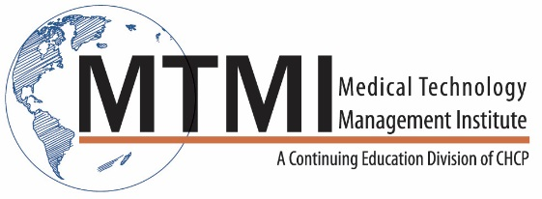
Sample Osteoporosis and the Clinical Utility of DXA Technology In-Service Course Agenda
8 Hour Program / 1 Day
The Revolution in Osteoporosis
- Who is at risk of Osteoporosis?
- Basic science of bone metabolism and remodeling
- Societal impact and consequences of fracture
DXA Bone Densitometry
- The Gold Standard: Operating principles, limitations and radiation safety
- Determination and value of BMD measurements: T-Scores and Z-Scores
- Quality Control – precision, assessment and accuracy
The Role of the DXA Technologist:
- Patient intake form
- Patient positioning, scan acquisition and analysis
- Communications and responsibilities for interpretations of DXA results
Bone Mass Measurement:
- Anatomical sites of importance: spine, proximal femur and forearms
- Scan analysis: specific regions of interest and the clinical diagnosis of Osteoporosis
- FRAX: calculations and assessment of absolute fracture risk and follow-up
- Important differences between various manufactures of DXA instruments
- Complimentary methods to DXA: Vertebral fracture assessment (VFA), bone biomarkers, quantitative ultrasound
Clinical Utility of DXA:
- DXA results in children and young adults
- Clinical vignettes: concerning PA spine, proximal femurs and VFA
- Troubleshooting DXA analyses: typical and complex situations, osteoarthritis, scollosis, prostheses, significant weight loss/gain, hyperparathyroidism, etc.
Reporting DXA results:
- Contents of a baseline and follow-up DXA report
- Proper use of Least Significant Change and FRAX
Clinical Management of Osteoporosis
- Prevention: the role of Calcium, vitamin D requirements and weight bearing exercise
- Current and newly approved treatments for Osteoporosis
- The myths and realities of osteoporosis treatment options, side effects
~ Agenda Subject to Change ~

800-765-6864 ~ custservice@mtmi.net ~ www.mtmi.net

