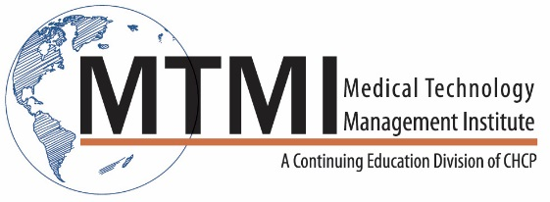

Sample Breast Ultrasound In-Service Course Agenda
8 Hour Program / 1 Day
Benign Pathologies
- Simple, Complicated and Complex Cysts
- Galactocele
- Sebaceous Cyst
- Fibrocystic Change
- Fibroadenoma
- Papilloma
- Lipoma
- Hamartoma
- Inflammation, Infection
- Trauma
- Gynecomastia
- Diabetic Mastopathy
Malignant Pathologies
- Common Ductal Neoplasm
- Common Lobular Neoplasm
- Uncommon Malignant Neoplasms
Mammographic and Sonographic Correlations
- Case Studies
Emerging Technologies

~ Agenda Subject to Change ~

800-765-6864 ~ custservice@mtmi.net ~ www.mtmi.net

