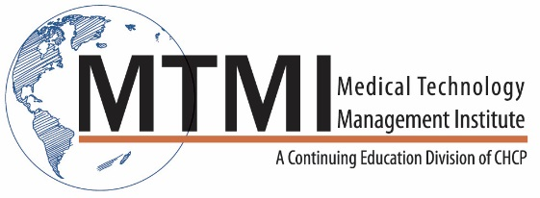
Radiation Safety & Changing Role of the Technologist
One Day Seminar (8 CE’s)
Introduction
- Tenets of Radiation Safety Philosophy
- ALARA: What does it truly mean from a clinical viewpoint?
- Risk vs. Benefit rationale
- Diagnostic Yield vs Diagnostic Efficacy
- Role of technologist and Diagnostic Yield
- Examples of imaging modalities and DY
Photon Interactions with Matter
- Concept of Electronic Data Set (EDS)
- Photoelectric and Compton effect
- Patient/operator dosage considerations
- Units of Measure and Dosage Considerations that have a Practical Application
Protection Measures for the Patient and Operator
- Cardinal rules of protection: Review and practical applications
- SID considerations and ESE dose, technique considerations
- Changing role of technologist as a radiation safety advocate
Dose Management Strategies
- Collective dose profile considerations
- Image Gently and Image Wisely
- ACE program (ASRT)
- Dose management strategies as a quality measure and future strategies
- Exposure Index and Deviation Index
- What do they mean in terms of image quality assessment and exposure
Basic Principles of Image Interpretation
- Basic radiographic densities and clinical examples
- How does the radiologist use these densities clinically?
- Low contrast resolution and its clinical value
- Boundary Effect and Mach Bands illusion
- Silhouette Sign Concept
- Clinical utility of Silhouette Sign
- Image impact of improper positioning and rotation
- Image quality expectations of radiologists (clinical image benchmarks)
- Chest imaging benchmarks
- Orthopedic image benchmarks
- Role of fat images
- Impact of digital technologies and detector designs

Professional Standards of Care for the Profession
- Technology impacting responsibilities
- The resurgence of radiography and why!
New Joint Commission (JC) standards impacting medical imaging

~ Agenda Subject to Change ~

800-765-6864 ~ custservice@mtmi.net ~ www.mtmi.net

